**Advanced Programming project: Employee Database**

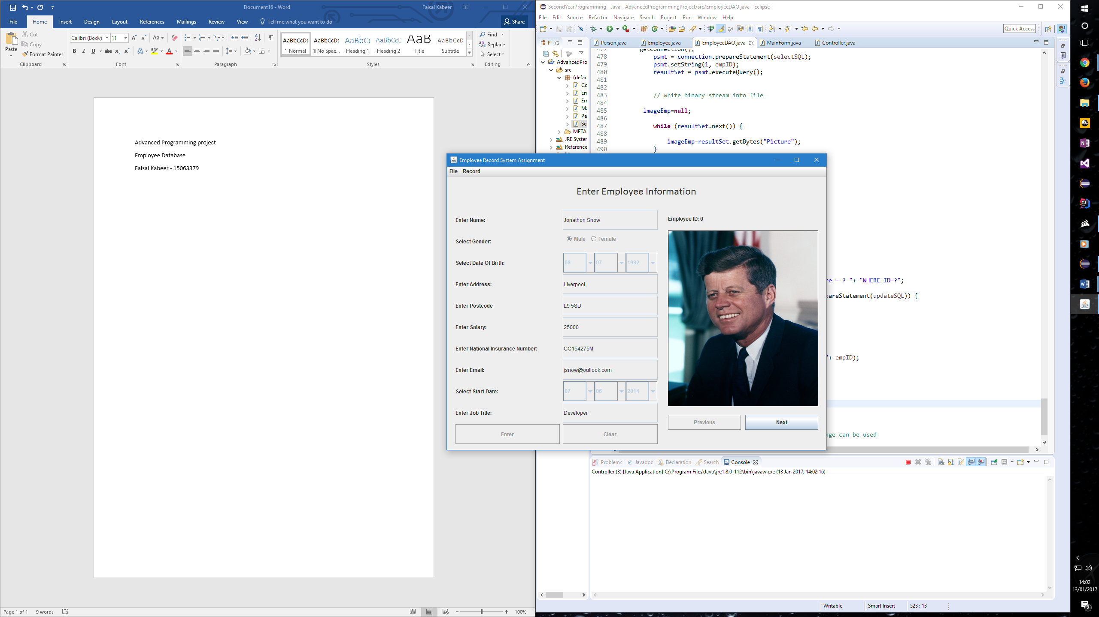

When first running the application, this is the main form area that displays. It features several text areas which have been made to be uneditable to the user, unless they click a feature which allows it to edit. They can still however view the data of that employee. The Previous and Next buttons allow the user to cycle through the employees in the database (if there is another employee in that direction).

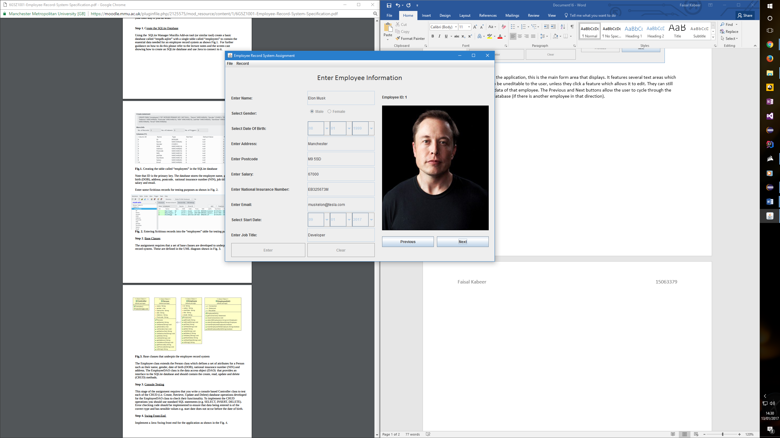

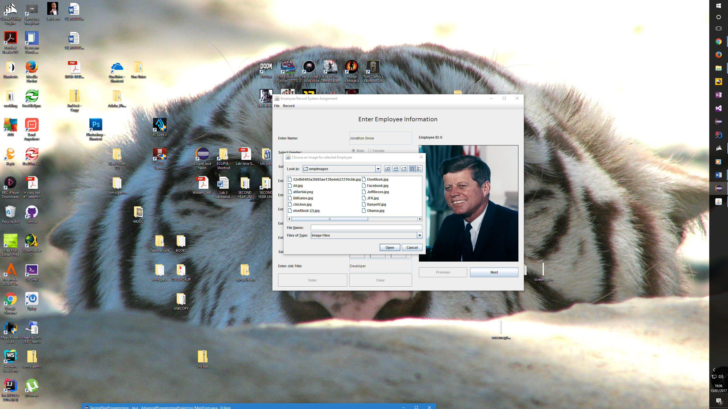

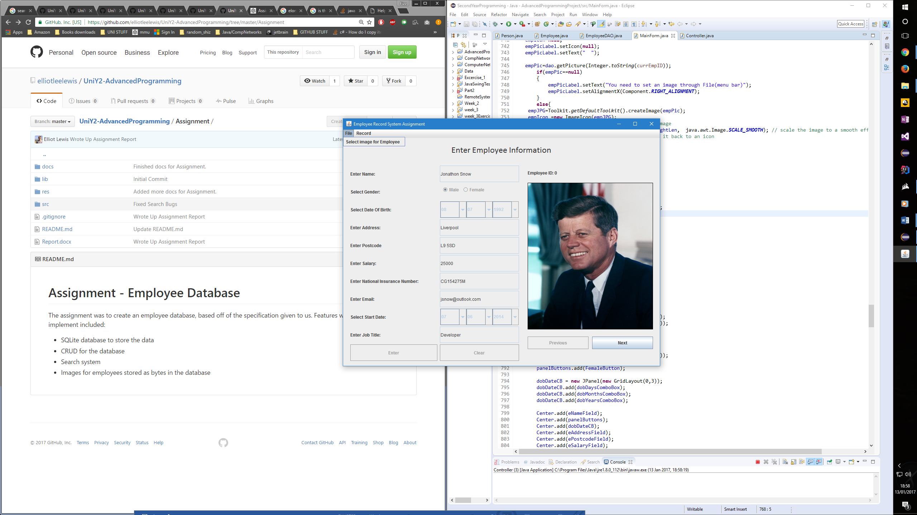

Under file, clicking select image for employee will open up a folder that will allow the user to select an image for the currently selected employee. Under Record it has several other features which include searching the database through names, adding an employee to the database, editing the current employee, deleting the current employee and deleting the current employees picture.

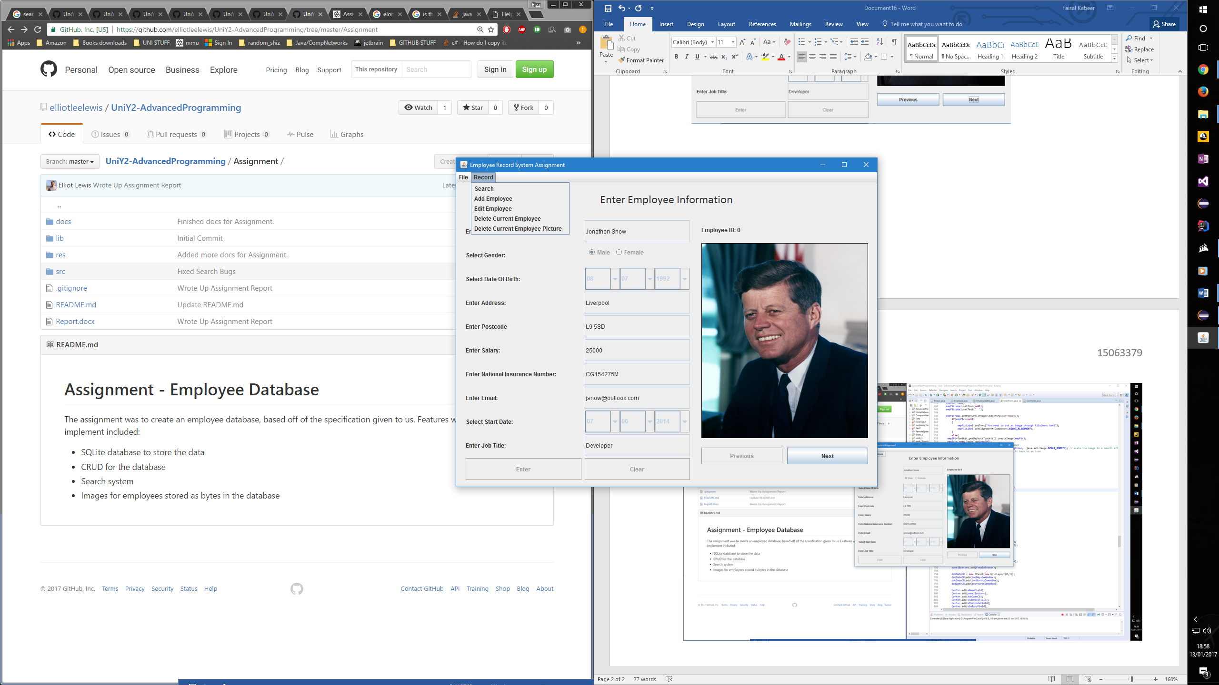

The search option opens a dialog box allowing you to enter part of the name you want to search for which then opens another dialog box which gives you all the names that had matched that criteria, if only one matches then only that option will display, clicking ok will display that employee.

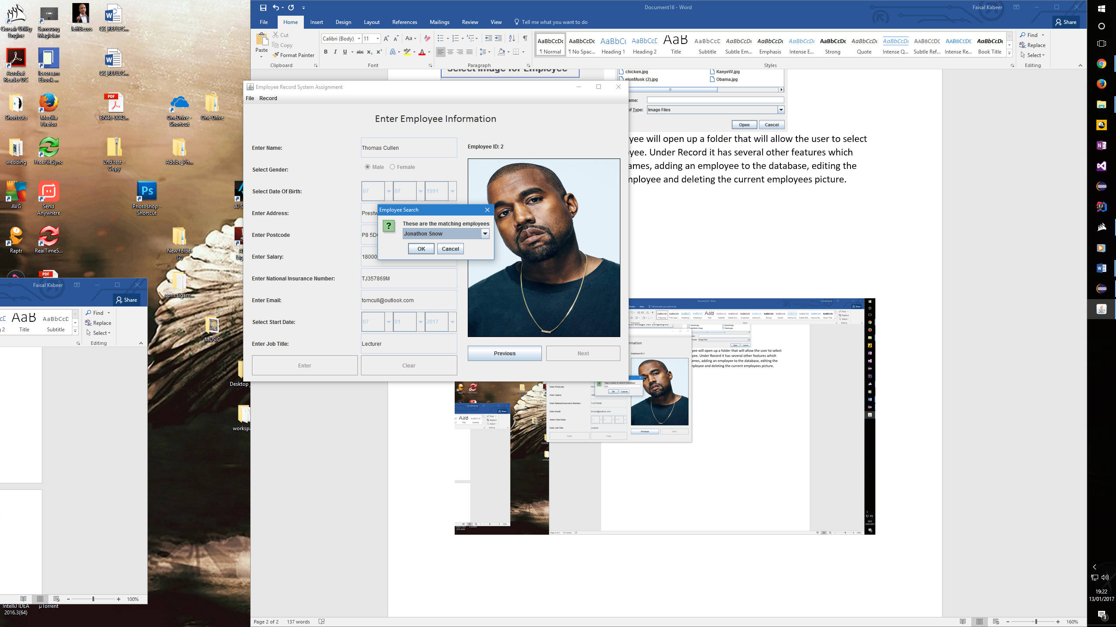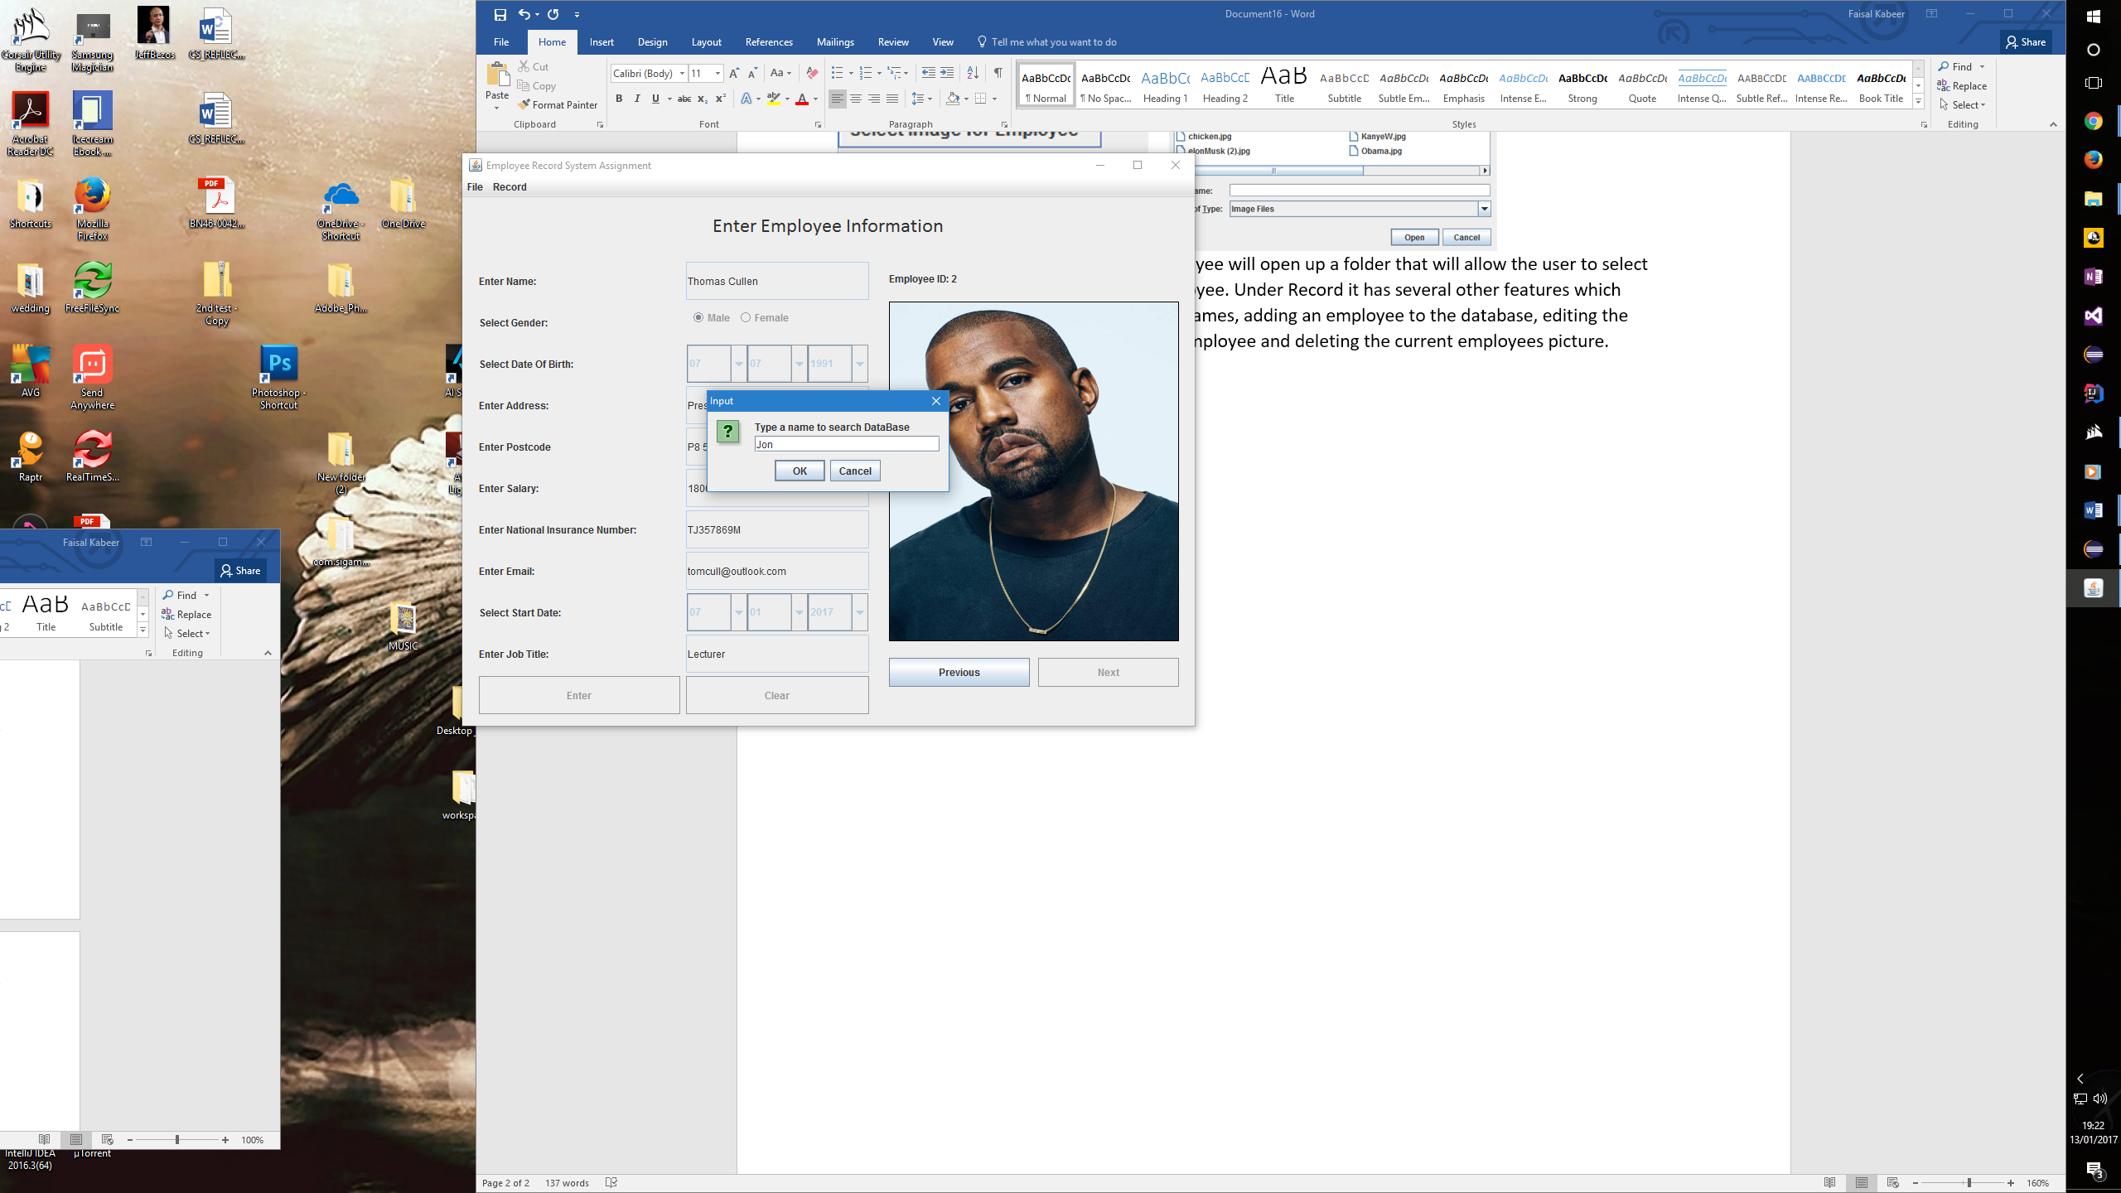

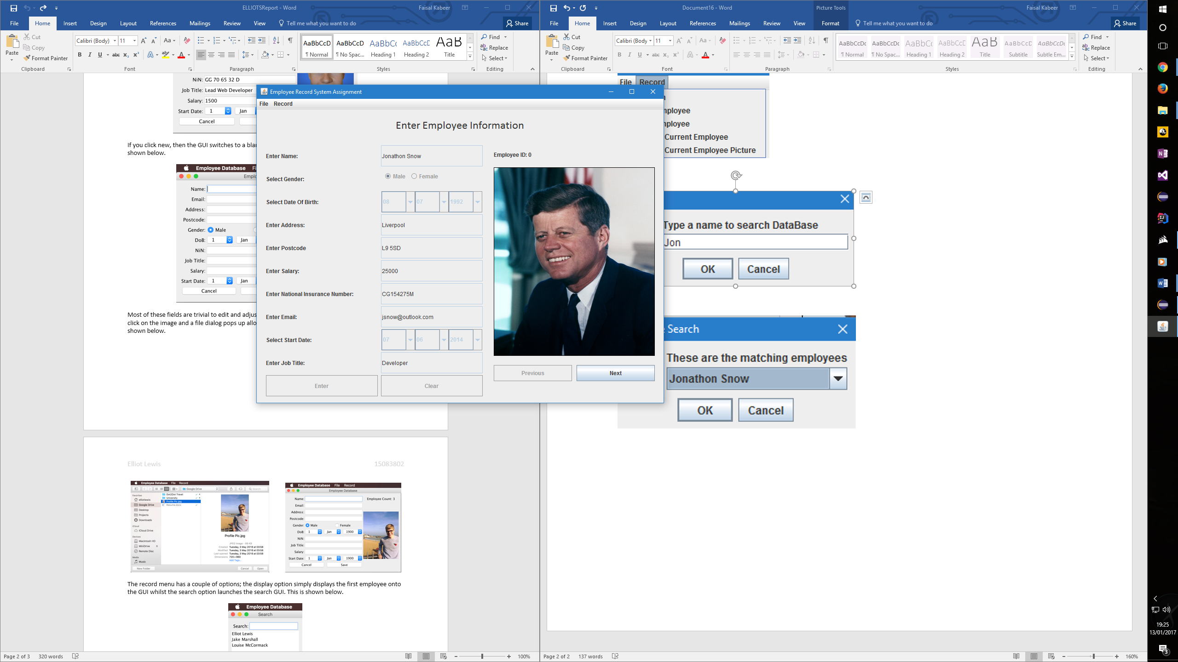

Add Employee produces a new blank data text fields while also notifies that an image is required for the employee as can be seen below. Everything requires thorough inputting as there is error checking preventing false data from being inserted.

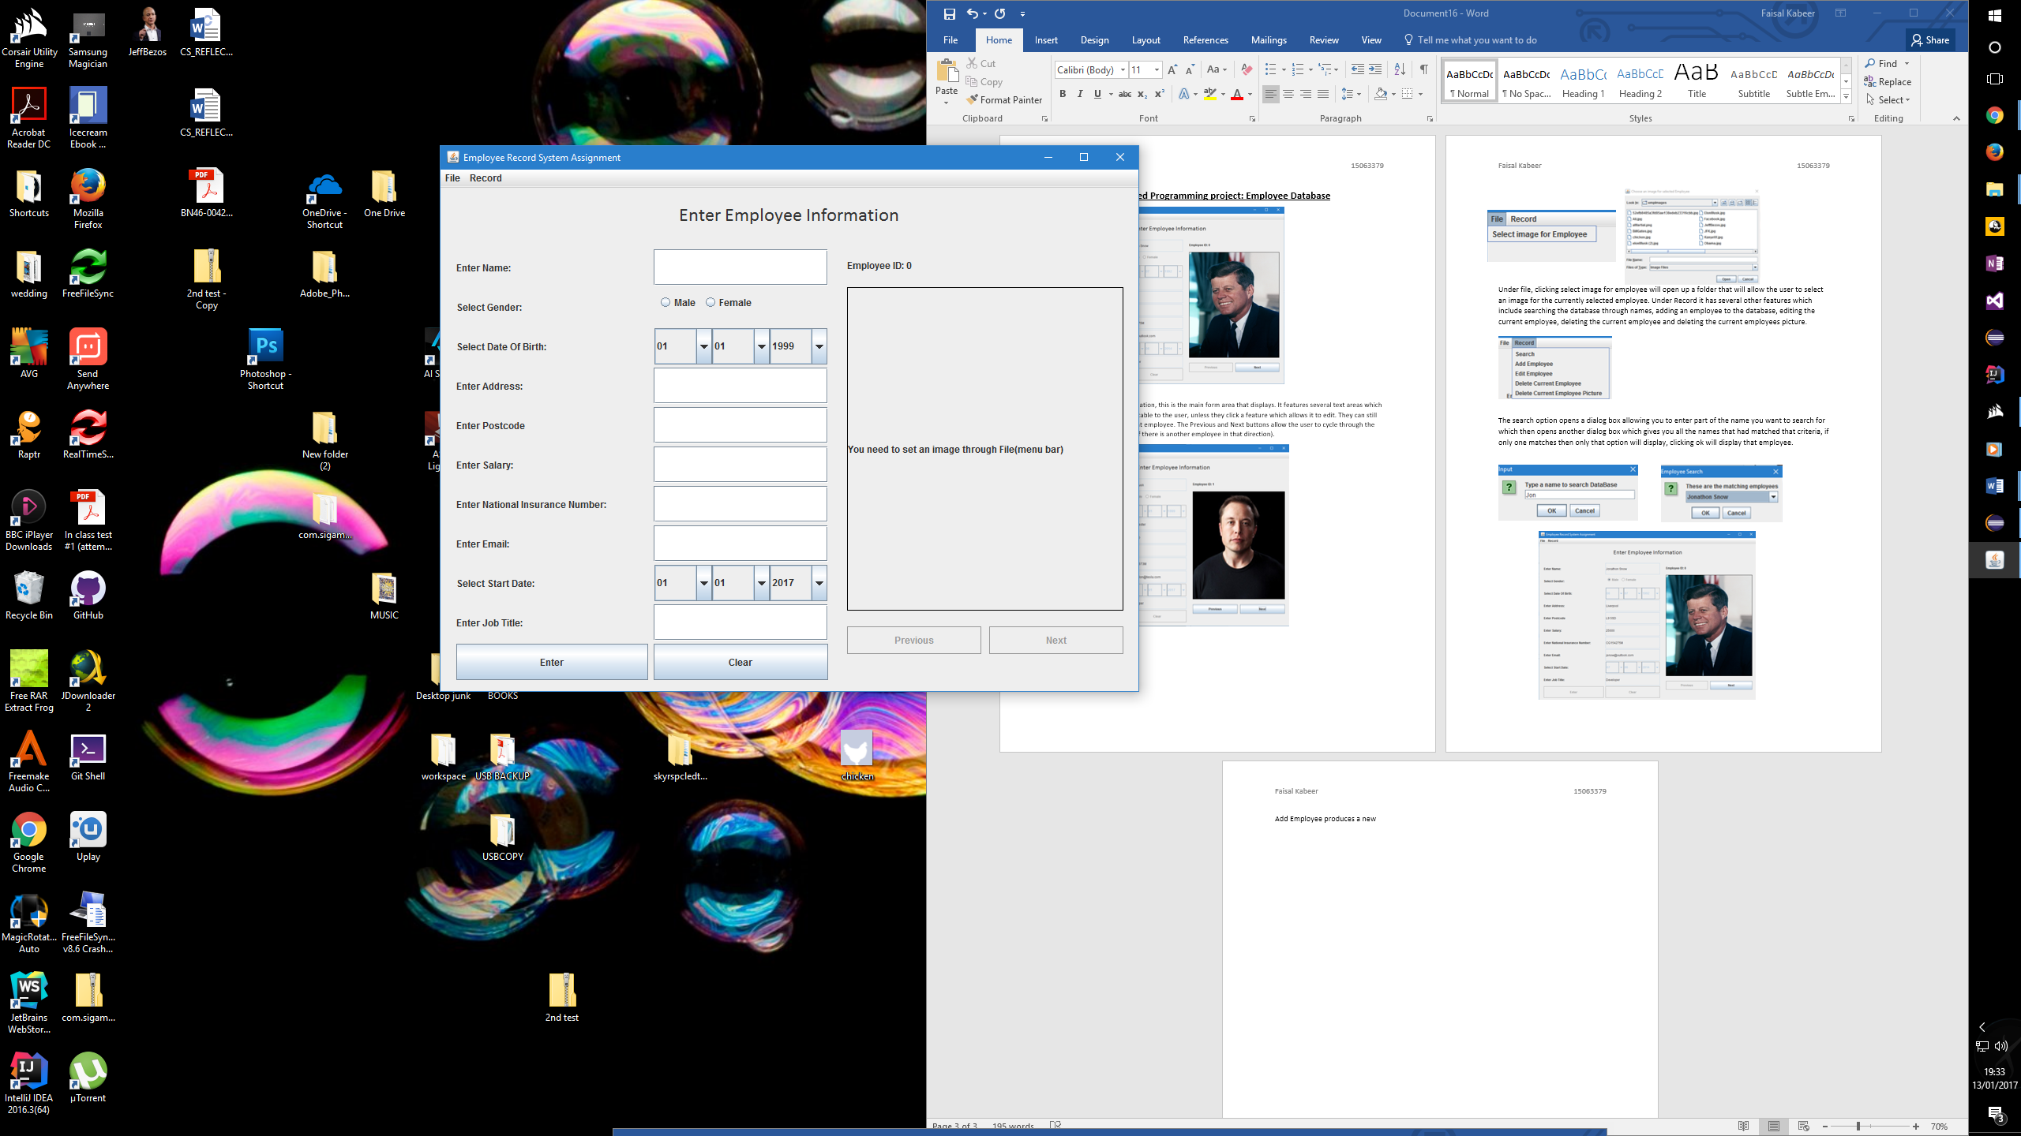

For example entering alphabetical values inside the salary, recieves this message.

